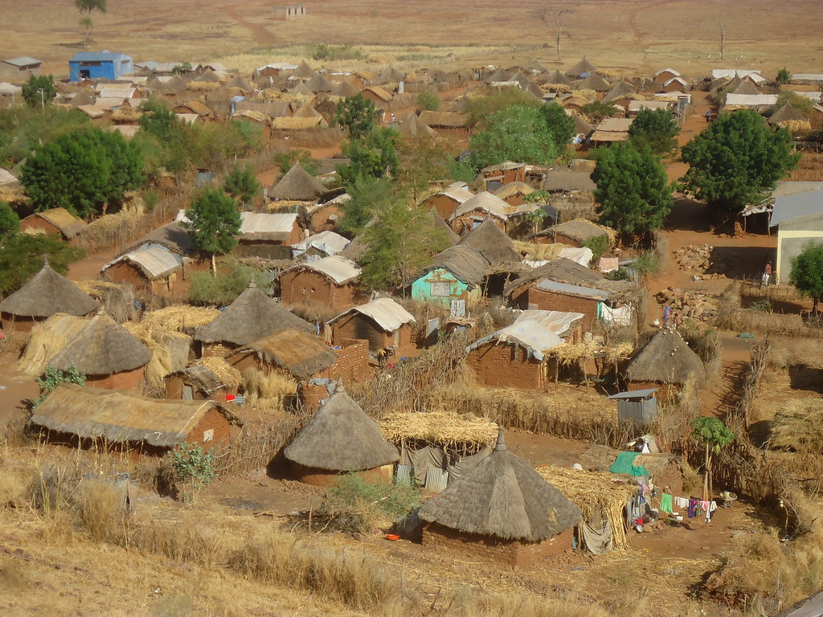
INFORMATION SHEET ON
Introduction to Housing, Land and Property rights

The Norwegian Refugee Council (NRC) is an independent humanitarian organization helping people forced to flee. We work in crises across 31 countries, providing life-saving and long-term assistance to millions of people every year.
NRC works to protect the rights of displaced and vulnerable persons during crisis. In Sudan, NRC is implementing programmes under the Water sanitation and hygiene, Food security and Livelihoods, Education, Shelter and settlement, Camp coordination & camp management, Information counselling & Legal Assistance areas of competence.
Information, Counselling & Legal Assistance (ICLA) is a legal aid programme seeking to assist displaced persons to claim and fulfil their rights through application of information, counselling and legal assistance services.
In Sudan NRC ICLA conducts activities on Housing Land and Property (HLP) issues, Civil and Identity Documentation and Employment laws and procedures.
THE NORWEGIAN REFUGEE COUNCIL
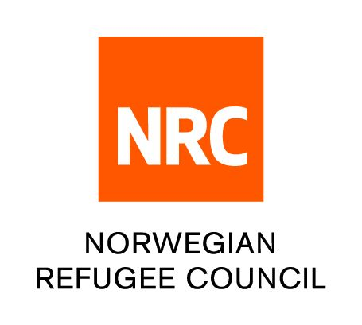
All information provided in this document is intended as a general guide only and is not a substitute for seeking advice from a qualified lawyer and/or government authorities. The information in this leaflet is subject to change and individuals should ensure that they obtain up to date information

HLP stands for (Housing Land and Property). It covers rights held over;
- All types of property; moveable and immoveable
- Land; this includes rights to use, control and transfers
- All forms of residency; including holding rights, tenant, customary land tenure owners
HLP rights are universally recognised human rights.
HOUSING RIGHTS
The right to housing is much more than having four walls and a roof over one’s head. Housing provides security and protection, privacy and personal space.
International law provide for the right to adequate housing which includes;
- Legal security of tenure - legal protection against forced eviction, harassment and other threats over the use and occupation of land’.
- Availability of services, materials, facilities and infrastructure: this includes safe drinking water, energy for cooking, heating and lighting, sanitation and washing facilities etc
- Affordability: affordable housing costs
- Habitability: adequate space, physical safety, and protection from cold, damp, heat, rain.
- Accessibility: adequate housing must be accessible to those entitled to it, including disadvantaged or vulnerable groups.
- Location: the house has to be in a location that allows access to employment and services such as health care, education.
- Cultural adequacy: the way in which the house is constructed has to allow for the expression of cultural identity.
In Sudan Chapter 3 of The Asylum (Organisation) Act 2014, recognises refugee’s right to housing and provides that they shall be given equal or better treatment than aliens with respect to their housing rights.
LAND RIGHTS
These are rights held over land and other natural resources. More than one person can hold rights over the same parcel of land. There are 3 categories of land rights:
- Use rights - the right to use the land for grazing, agricultural activities and collecting forestry and other natural products
- Control rights - the right to make decisions about how the land should be used and how benefits should be allocated
- Transfer rights - the right to sell land, transmit the land through inheritance and reallocate use and control rights
Section 13(2) of the Asylum (Organisation) Act 2014 13(2) provides that; refugees can acquire movable property; and they can acquire immovable property, after obtaining the approval of the Council of Ministers.
PROPERTY RIGHTS
This refers to any moveable or immoveable product over which the rights of possession, use and enjoyment are exercised
There are two kinds of property;
- Real property (land or anything attached to it -immoveable) – generally refers to land and anything erected on, growing on, or affixed to it, including buildings.
- Personal property (anything else - moveable) i.e. money
Section 13(2) of The Asylum (Organization) Act 2014 recognizes refugees rights to acquire moveable property in Sudan.
Section 8 of the Regulation of Asylum Act 1974 requires all refugees to register the particulars of all movable property which they bring into the Sudan so as to permit him to take them away upon return to their country of origin or when they seek asylum in another country.
THE DIGITAL COMMUNITY HUB
- Call NRC for free on 015 655 9807
- Information available in English, Arabic, Tigrinya and Amharic (from 8:00 AM to 4:00 PM every day).
- If you are a Refugee or Internally Displaced Person in Khartoum, get information on obtaining legal documents and on our Cash for Food Programme.
- The call will not cost you anything.
- You can also leave us a message with your complaint or feedback on our services and we wll get back to you (Sunday - Thursday, between 8:00 AM and 4:00 PM)
www.nrc.no

